ASMP PROJECT REPORT

ON

“Online Voting System Using Blockchain”

Submitted to Parul Institute Of the technology

Submitted By

1. Kunal kumar shaw
2. Sanjeev
3. Ravindra Sahani
4. Samanjoy Das

Under the Guidance of

Prof. khusboo ####

**TABLE OF CONTENTS**

**TITLE Page No.**

1. ABSTRACT
2. INTRODUCTION
3. LITERATURE SURVEY
4. PLAN OF WORK
5. DATA ANALYSIS AND RESULT
6. SUMMARY

**ABSTRACT**

In any democratic country, Voting is a fundamental right of any citizen that enables them to choose the leaders of tomorrow. It gives individuals in a community the facility to voice their opinion. It helps them to realize the importance of citizenship. Online voting systems are software platforms used to securely conduct votes and elections. As a digital platform, they eliminate the need to cast your votes using paper or having to gather in person. They also protect the integrity of your vote by preventing voters from being able to vote multiple times.

Electronic voting or e-voting has fundamental benefits over paper based systems such as increased efficiency and reduced errors. The electronic voting system tends to maximize user participation, by allowing them to vote from anywhere and from any device that has an internet connection. The blockchain is an emerging, decentralized, and distributed technology with strong cryptographic foundations that promises to improve different aspects of many industries. Expanding e-voting into blockchain technology could be the solution to alleviate the present concerns in e-voting. Here we propose a blockchain-based voting system that will limit the voting fraud and make the voting process simple, secure and efficient.

**Chapter-1**

**INTRODUCTION**

* 1. **Overview:**

India is a democratic country and has a democratic country. As now all Indian citizen become a part of the growing digital India with a digital ID that is Aadhaar card. Voting schemes have evolved from counting hands in early days to systems that include paper, punch card and electronic voting machine.

**EXISTING SYSTEM**

The Existing System of Election is running manually. The Voter has to Visit to Booths to Vote a Candidate so there is wastage of Time. Due to this many people don’t go out to cast their vote which is one of the most important and Worrying factor. In democracy Each and every vote is important. This Traditional system can be replaced by a new online system which will limit the voting frauds and make the voting as well as counting more efficient and transparent.

**PROPOSED SYSTEM** :

The current voting system requires some improvement in it because of the issues mentioned above. This can be achieved by replacing the existing system by the new system which will limit the voting frauds and make the voting as well as counting more efficient.

* + Online Election System would have user registration, user login and admin login.
  + This Online Voting System will manage the Voter’s information by which voter can login and use his voting rights.
  + At the time of registration voter will be asked for this: Full name, age, Aadhaar card no, mobile no. email id and after being verified will be given the access.
  + At the time of requesting vote, voter will be asked to enter his Aadhaar id. Then voter will be authenticated, and he can give vote from one of the candidate from the list .Voters can vote for a Candidate only once per Election.
  + The software system allows the user to login in to their profiles and upload all their details including their previous milestone onto the system. The admin can check each Candidate details.
  + The software system also allows Voters to view a list of Candidates in their area. The admin has overall rights over the system and can moderate and delete any details not pertaining to Election Rules.
  1. **PROBLEM STATEMENT:**

Building a secure electronic voting system that offers the fairness and privacy of current voting schemes, while providing the transparency and flexibility offered by electronic systems has been a challenge for a long time. In this work-in-progress paper, we evaluate an application of blockchain as a service to implement distributed electronic voting systems. The paper proposes a novel electronic voting system based on blockchain that addresses some of the limitations in existing systems and evaluates some of the popular blockchain frameworks for the purpose of constructing a blockchain-based e-voting system. In particular, we evaluate the potential of distributed ledger technologies through the description of a case study; namely, the process of an election, and the implementation of a blockchain based application, which improves the security and decreases the cost of hosting a nationwide election.

* 1. **OBJETIVE OF PROJECT:**
* The objective is to have faster and more accurate vote counting that is also very easy for people to use.
* The voting system must be trustworthy and high security .
* All voter get assured about the privacy of votes and prevent selling of votes.
* The voting system must be transparent in which voter can see their vote.
* The voting system tends to maximize user participation, by allowing them to vote from anywhere and from any device .
* By considering the importance of the e-voting system is implemented using “Blockchain”.
* The reduction in organizational and implementation costs significantly increases the efficiency of election management compared to traditional paper voting, for example.

**1.4 APPLICATION OR SCOPE:**

* **General Election**: once every five years , a general election is held , in which all eligible voter user their rights. Member of Lok Sabha are chosen directly by voting in general election.
* **State Assembly Elections:** Members of the state legislature are chosen directly by voting, in which all citizens have the right to vote in their constituency.
* **Rajya Sabha Election:** In a Rajya Sabha election, only the State Legislative Assemblies members have the right to vote. A group of MPs from one or more parties has the power to elect a member of their choice. In the Rajya Sabha, each MP has a Five-year term.
* **Local Body Elections:** Local elections are held once every two years in India to elect local government officials such as mayors and councilors. A returning officer oversees each municipal election.

In all such election , our application will prove to be a milestone as it is trustworthy , without intervention of middle man , immutable and consistent.

Apart all from this, we all know that there are many organization that conduct election for the position like “Group Leader, Project Leader, Employee of the month” etc. In this case online voting system helpful to conduct vote. People can cast their vote from anywhere.

As college conduct elections for position like president, vice president , vice president etc. for many college societies like CSI , trinity etc , and other management posts for student and online voting system can be used on any cases like these efficiently. It can be customized according to client need on any type of election.

* 1. **ORGANISATION OF REPORT:**

**CHAPTER-2**

**LITERATURE SURVERY**

Currently increasing digital technology helped many people lives. In contrast to the electoral system, there are many conventional uses of paper in its implementation. The aspect of security and transparency is a threat from still widespread election with the conventional system. Block chain technology is one of solutions, because it embraces a decentralized system and the entire database are owned by many users. There is no doubt that the revolutionary concept of the blockchain, which is the underlying technology behind the famous crypto currency Bit coin and its successors, is triggering the start of a new era in the Internet and the online services. In this work, we have implemented and tested a sample e-voting application as a smart contract for the Ethereum network using the Ethereum wallets and the Solidity language. Block chain was first introduced by Satoshi Nakamoto (a pseudonym), who proposed a peer to-peer payment system that allows cash transactions through the Internet without relying on trust or the need for a financial institution. Block chain is secure by design, and an example of a system with a high byzantine failure tolerance. E-voting is a potential solution to the lack of interest in voting amongst the young tech savvy population. For e-voting to become more open, transparent, and independently auditable, a potential solution would be base it on block chain technology. Block chain technology has a lot of promise; however, in its current state it might not reach its full potential.

Electronic voting has been used in varying forms since 1970s with fundamental benefits over paper based systems such as increased efficiency and reduced errors. With the extraordinary growth in the use of block chain technologies, a number of initiatives have been made to explore the feasibility of using block chain to aid an effective solution to e-voting. It presented one such effort which leverages benefits of block chain such as cryptographic foundations and transparency to achieve an effective solution to e-voting. The proposed approach has been implemented with Multichain and in-depth evaluation of approach highlights its effectiveness with respect to achieving fundamental requirements for an e-voting scheme.

**1.1 Agarwal, H. and Pandey, G.N., 2013, November. Online voting system for India based on AADHAAR ID. In *2013 Eleventh International Conference on ICT and Knowledge Engineering* (pp. 1-4). IEEE.**

The work in paper is focusing about the AADHAAR ID based online system. Generally it give better understanding of system overview that what is the flow of system. The work paper focusing on client-survey architecture for creating and casting the vote. It briefly explain the system overview:

* Uploading voter information
* Uploading candidate Information
* Date and time of Election
* Election day
* Vote submission
* Acceptance of vote by the server
* Cross check/ verification of votes
* Result declaration

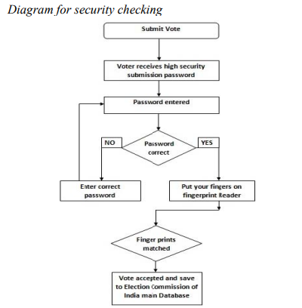

This paper describes the proposed model for online voting system for India. The proposed system is much secure and efficient than the traditional voting system. Manipulation of votes and delay of results can be avoided easily. A unique AADHAAR identity is the centre point of our proposed model. It leads to the easier verification of both voters and candidates.

**Limitation:** But the following architecture does not solve security related challenges as it is client -server system and there is single authority to handle the entire system which challenge the voter identity and integrity.

**1.2 Jafar, U., Aziz, M.J.A. and Shukur, Z., 2021. Blockchain for electronic voting system—review and open research challenges. *Sensors*, *21*(17), p.5874.**

The work in this paper mainly focus on the implementation digital voting system based on Blockchain technology. Paper elaborate the blockchain technology.

**1.2.1 BLOCKCHAIN AND SMART CONTRACT**: The first things that come to mind about the blockchain are cryptocurrencies and smart contracts because of well-known initiative in Bitcoin and Ethereum. The concept of smart contract was introduced was much earlier by Nick Szabo in the 1990s and described as “a set of promises , specified in digital form, including protocols within which the parities perform on these promises”.

In Ethereum, a smart contract is a piece of code deployed to the network so that everyone has access to it. The result of executing this code is verified by a consensus mechanism and by every member of the network as a whole.

*The blockchain structure:*

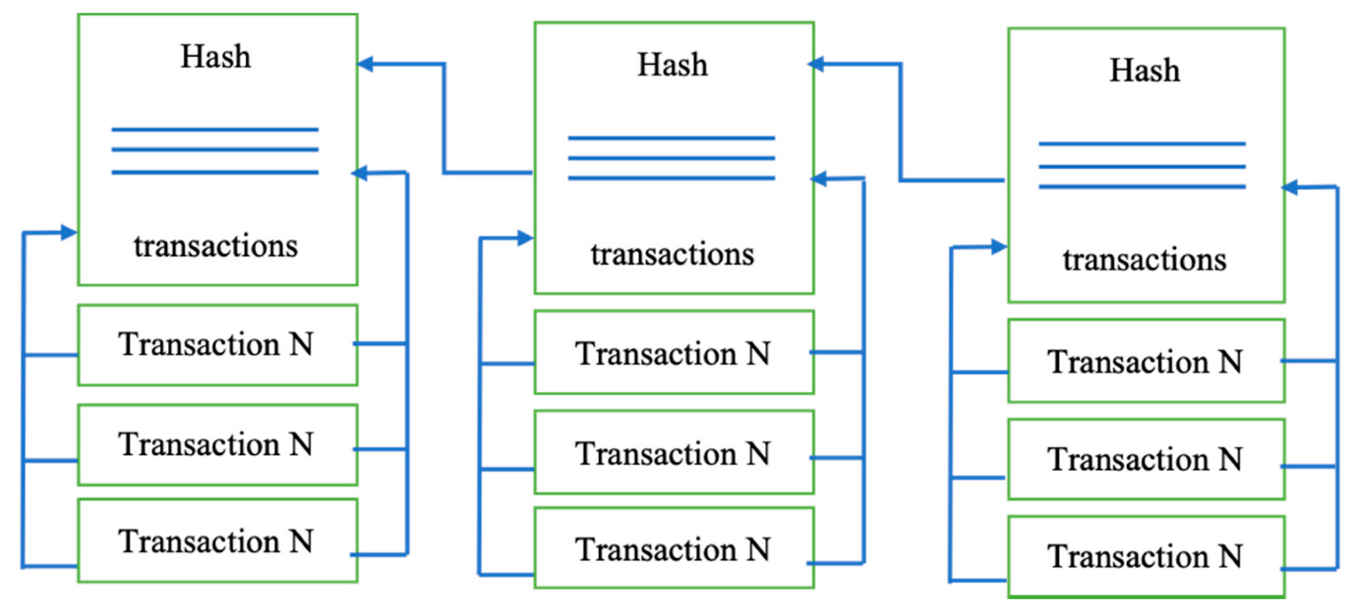

**1.2.2** Blockchain is a distributed, immutable, incontrovertible, public ledger. This new technology has three main features:

1. **Immutability**: Any proposed “new block” to the ledger must reference the previous version of the ledger. This creates an immutable chain, which is where the blockchain gets its name from, and prevents tampering with the integrity of the previous entries.
2. **Verifiability:** The ledger is decentralized, replicated and distributed over multiple locations. This ensures high availability (by eliminating a single point of failure) and provides third-party verifiability as all nodes maintain the consensus version of the ledger.
3. **Distributed Consensus:** A distributed consensus protocol to determine who can append the next new transaction to the ledger. A majority of the network nodes must reach a consensus before any new proposed block of entries becomes a permanent part of the ledger.

#### 1.2.3 *Core Components of Blockchain Architecture*

These are the main architectural components of Blockchain

* 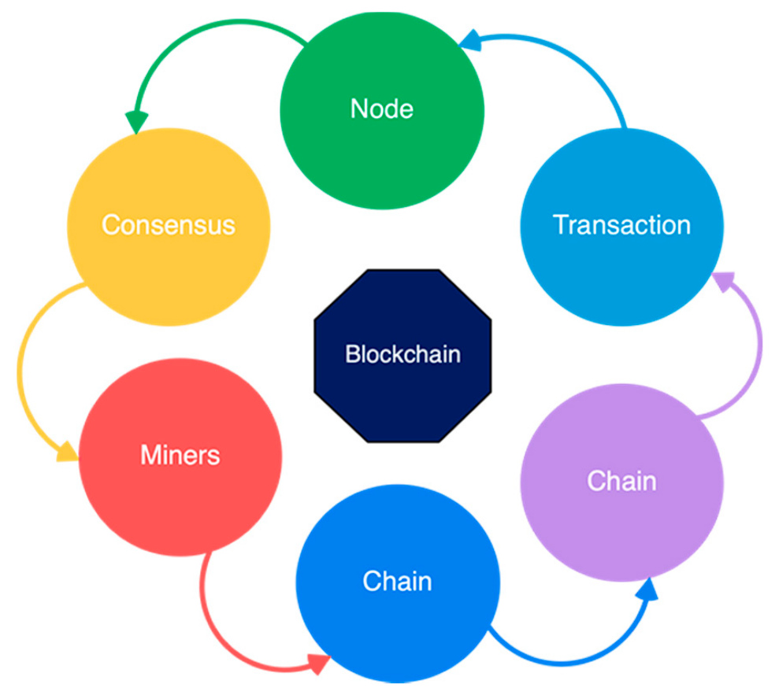
* **Node:** Users or computers in blockchain layout (every device has a different copy of a complete ledger from the blockchain);
* **Transaction:** It is the blockchain system’s smallest building block (records and details), which blockchain uses;
* **Block:** A block is a collection of data structures used to process transactions over the network distributed to all nodes.
* **Chain:** A series of blocks in a particular order;
* **Miners**: Correspondent nodes to validate the transaction and add that block into the blockchain system;
* **Consensus:** A collection of commands and organizations to carry out blockchain processes.

**1.2.**3  *Critical Characteristics of Blockchain Architecture*

Blockchain architecture has many benefits for all sectors that incorporate blockchain. Here are a variety of embedded characteristics as described

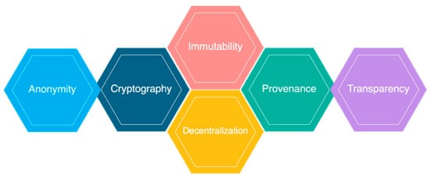

* Cryptography: Blockchain transactions are authenticated and accurate because of computations and cryptographic evidence between the parties involved;
* Immutability: Any blockchain documents cannot be changed or deleted;
* Provenance: It refers to the fact that every transaction can be tracked in the blockchain ledger;
* Decentralization: The entire distributed database may be accessible by all members of the blockchain network. A consensus algorithm allows control of the system, as shown in the core process;
* Anonymity: A blockchain network participant has generated an address rather than a user identification. It maintains anonymity, especially in a blockchain public system;
* Transparency: It means being unable to manipulate the blockchain network. It does not happen as it takes immense computational resources to erase the blockchain network.

## How Blockchain Can Transform the Electronic Voting System

Blockchain technology fixed shortcomings in today’s method in elections made the polling mechanism clear and accessible, stopped illegal voting, strengthened the data protection, and checked the outcome of the polling. The implementation of the electronic voting method in blockchain is very significant [[**35**](https://www.mdpi.com/1424-8220/21/17/5874#B35-sensors-21-05874)]. However, electronic voting carries significant risks such as if an electronic voting system is compromised, all cast votes can probably be manipulated and misused. Electronic voting has thus not yet been adopted on a national scale, considering all its possible advantages. Today, there is a viable solution to overcome the risks and electronic voting, which is blockchain technology. In [**Figure 4**](https://www.mdpi.com/1424-8220/21/17/5874#fig_body_display_sensors-21-05874-f004), one can see the main difference between both of the systems. In traditional voting systems, we have a central authority to cast a vote. If someone wants to modify or change the record, they can do it quickly; no one knows how to verify that record. One does not have the central authority; the data are stored in multiple nodes. It is not possible to hack all nodes and change the data. Thus, in this way, one cannot destroy the votes and efficiently verify the votes by tally with other nodes. 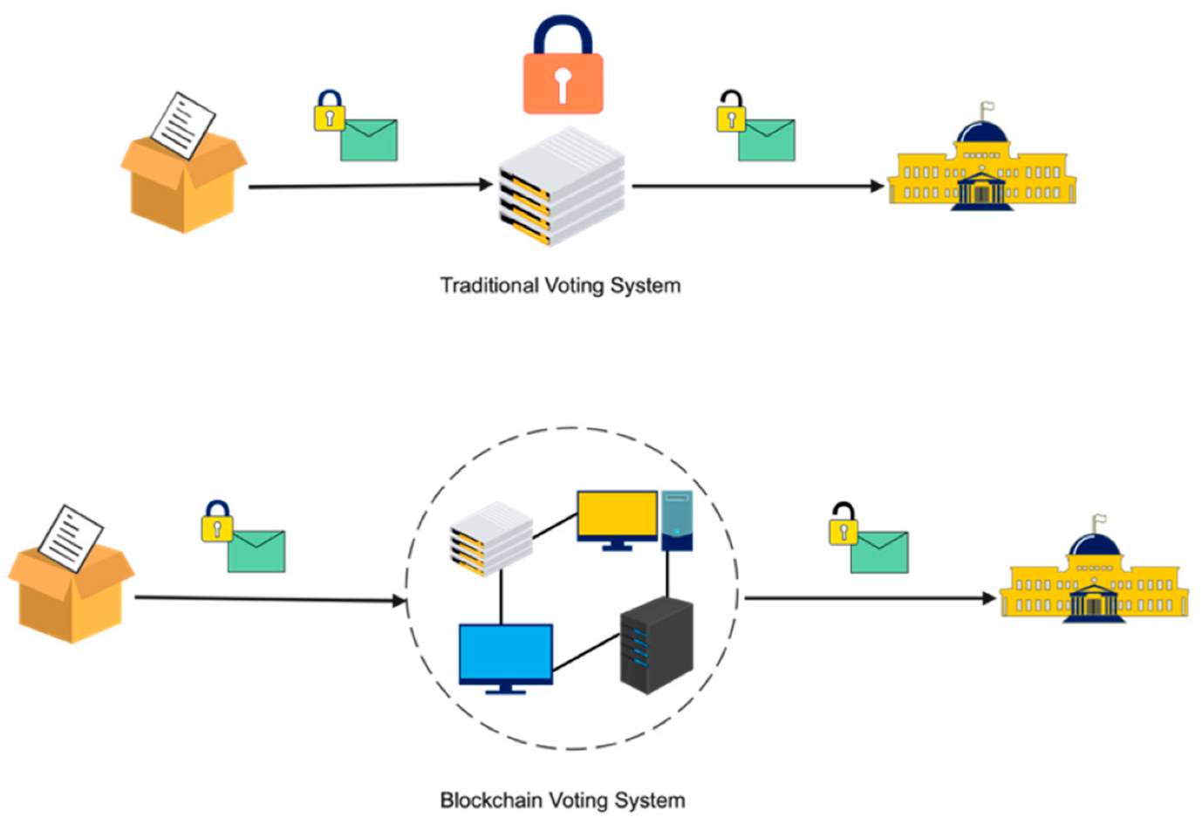

**Chapter-3**

**METHODOLOGY**